A

PROJECT REPORT

ON

“LIBRARY MANAGEMENT”

Submitted To

V.P.M.P. POLYTECHNIC

DEPARTMENT OF COMPUTER
ENGINEERING



Internal guide: Developed by:

PREETI GAJJAR SHRUSHTI PRAJAPATI(206540307011)

VISHWA PATEL(206540307154)

V.P.M.P. POLYTECHNIC

DEPARTMENT OF COMPUTER ENGINEER



CERTIFICATE

This is to certify that Mr./Miss. VISHWA PATEL. Of 20CE2 class, Enrollment No.206540307154 has satisfactory complement his/her term work in PROJECT-2(3360707) for the term ending in May 2023.

Date:

Sign of Internal Guide Sign of H.O.D
Mrs. Preeti Gajjar Mrs. Kiran Jha

V.P.M.P. POLYTECHNIC

DEPARTMENT OF COMPUTER ENGINEER



CERTIFICATE

This is to certify that Mr./Miss. SHRUSHTI PRAJAPATI. Of 20CE2 class, Enrollment No.206540307011 has satisfactory complement his/her term work in PROJECT-2(3360707) for the term ending in May 2023.

Date:

Sign of Internal Guide Sign of H.O.D
Mrs. Preeti Gajjar Mrs. Kiran Jha

Acknowledgement

Many people have helped to make this project work Possible. It is my pleasure to acknowledge and thank them for their valuable co-operation at various stages of this work.

First and fore most I like to offer my gratitude to The Almighty God to send me his blessings and to give me an opportunity to reach up to this level.

I would like to express my intense feeling of gratitude towards my guide Mrs. Preeti Gajjar for her extremely good suggestions, guidance and constant inspiration.

Then I would like to express my sincere Thank to my Head of Department Mrs. Kiran Jha and our principal Dr. Prakash Patel for their valuable and timely co-operation.

I express my obligation and thanks to all the facility member pf C.E. Department as well as my parents for kind support and motivation that they offered me during my work.

Patel Vishwa (20654030154)
Prajapati Shrushti(206540307011)

Abstract

The Library Management is an application for assisting a librarian
In managing a book library in a university. The system would provide basic
set of features to add/update members, add/update books, and manage check in specifications for the systems based on the client’s statement of need. Library management system is a typical management Information
system (MIS), its Development include the establishment and maintenance
of back-end database and front-end application development aspects. For
the former require the establishment of data consistency and integrity of
the strong data security and good libraries. As for the latter requires the
application fully functional, easy to use and so on.

INDEX | Page  no.
1. Introduction
1.1 Project Profile  1.2 Project Summary  1.3 Purpose Goals & Objectives  1.4 General Description | 6  7  8  9
2. System Requirements
2.1 User Characteristics  2.1.1 Admin  2.1.2 Student  2.2 Hardware and Software Requirements  2.3 Functional & Non-Functional Requirements  2.4 Introduction PHP | 10  10  11  12  13  14
3. System Design
3.1 E-R Diagram  3.2 Use Case Diagram  3.3System Flowchart  3.4Data flow Diagram | 17  18  19  20
4. Data Dictionary
4.1 Student Table  4.2 Book Table  4.3 Admin Table  4.4 Category Table | 21  21  22  22
5. Snap Shot | 24
5.1 Student Registastion  5.2 Student sign in  5.3 Admin Sign In  5.4 Welcome Admin Page  5.5 Issue Book  5.6 Request for Unavailable Book  5.7 Change Password | 25  26  27  28  29  30  31
6.Bibliography  6.1 Book name  6.2 Website Name | 32  33

1.Introduction

1.1 Project Profile

Project Definition | Library Management System
Category | Website
Team Members | PATEL VISHWA  PRAJAPATI SHRUSHTI
Team Size | 2
Project Type | UDP
Internal Guide | Prof. PREETI GAJJAR
Technology Used | PHP
Tools | Visual Studio Code
Front End | PHP
Back End | My SQL
Operating System | Windows
Collage Name | VPMP polytechnic Gandhinagar

1.2 Project Summary

- The “Library management” is a platform where anybody can show book, add book, renew book, etc.

- Here admin who want to manage his/her book, they can register their self and put their books and some required detail about books.

- There is no charge for this kind of process it is for student’s help.

- This website is helpful mostly for students.

1.3 Purpose: Goals and Objectives

GOALS:

- User friendly input screen.

- Borrowed book list.

- Available book list.

- Search for books and members.

OBJECTIVES:

- The main objective of the Library Management is to manage the details of Address, Member, Issues, Books, Student.

- It manages all the information about Address, Librarian, and Student.

- The project is totally built at administrative end and thus only the administrator is guaranteed the access.

1.4 General Description

EXISTING SYSTEM DRAWBACKS:

- System provide Library Management System so this process is time consuming.
- Manually system furnish advertise through of newspaper, agent, banner, channel so on.
- System does not provide facility such as contact, email So on.

ADVANTAGES OF PROPOSED SYSTEM:

- Our system is easy to use.

- Everyone can easily register their account on site.

- They can also upload a picture of their Book’s details.

- We have provided a good interface for the novice users.

- Any Student can easily find Book by choosing their department.

- Any Student can simply use this service on mobile as well as computer with Internet facility.

- The system is available 24*7 a week, and any mobile or computer enabled with internet facility can use the system.

2. System Requirements
2.1 User Characteristics

- There are 2 types of users who deals with system.

- Admin
- Student

2.1.1 Admin

1. Login
2. Add Books
3. Book Issue
4. Book Requests
5. Change Password
6. Log out

2.1.2 Student:

- Log in
- Register
- Forget password
- Select Book
- Request Book Details
- Log out

2.2 Hardware and Software requirement

- Software Requirements

- Operating system: Window 7 & 10 or Any Compatible Server OS

- Front end: Html, CSS & JavaScript

- Back end: PHP

- Database: XAMPP

- Technology: PHP

- ^{Hardware Requirements}
- Processer: Intel Core 15 v pro
- Ram: 1GB (Minimum)
- Hard Disk: 10 GB (Minimum)
- Keyboard: Standard 102 Keys
- Mouse: 3 Keys

2.3 Functional and Non-functional requirements

- Functional Requirements

- A transporter shall be able to search our website.

- The system shall provide food details.

- Every user has their unique credentials to upload food for transport.

- There is no need to any kind of credentials to find food.

- Non-functional requirements:

- The system shall be accessible for any people.

- Once transporter is login than the system shall be available for upload property and provide appropriate details and price for property.

- Without registration user cannot able to find food or trucks.

- For registration password must have length of 8 or more.

- User need to provide for search foods and trucks.

- Mentioned field are required to appropriate result and best deals.

2.4 Introduction of PHP

What is a PHP File?


    - PHP files can contain text, HTML, CSS, JavaScript, and PHP code PHP code are executed on the server, and the result is returned to the browser as plain HTML
    - PHP files have extension ".PHP"

What Can PHP Do?

    - PHP can generate dynamic page content
    - PHP can create, open, read, write, and close files on the server
    - PHP can collect form data
    - PHP can send and receive cookies
    - PHP can add, delete, modify data in your database
    - PHP can restrict users to access some pages on your website
    - PHP can encrypt data
    - With PHP you are not limited to output HTML. You can output images, PDF files, and even flash movies. You can also output any text, such as XHTML and XML.

Why PHP?

- PHP runs on various platforms (Windows, Linux, Unix, Mac OS X, etc.)
    - PHP is compatible with almost all servers used today (Apache, IIS, etc.)


    - PHP supports a wide range of databases PHP is free. Download it from the official PHP resource: www.php.net PHP is easy to learn and runs efficiently on the server side

Features of PHP:

- HTTP authentication with PHP
- Functions restricted/disabled by safe mode
- Command line usage — Using PHP from the command line
- Options — Command line options
- Usage — Executing PHP files
- I/O streams — Input/output streams
- Cookies
- Sessions
- Dealing with X Forms
- Handling file uploads
- Common Pitfalls
- uploading multiple file
- Security and Safe Mode
- Performance Considerations
- DT race Dynamic Tracing

3. System Design

- 3.1 E-R Diagram

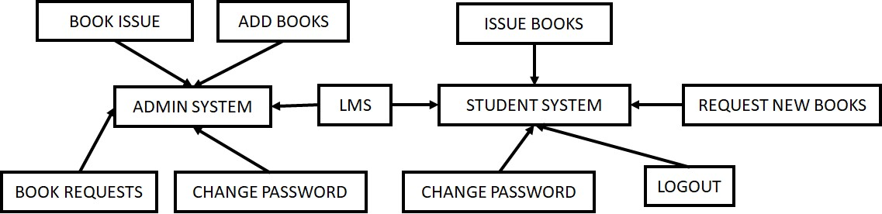

- 3.2 Use Case Diagram

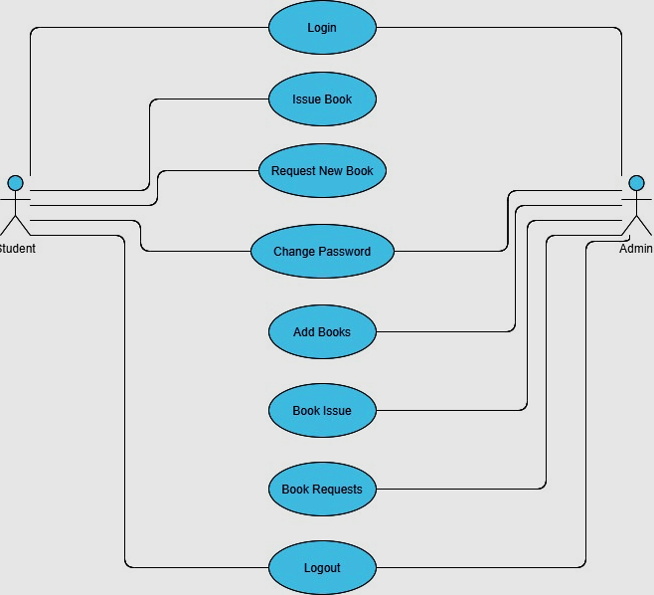

- 3.3 System Flowchart

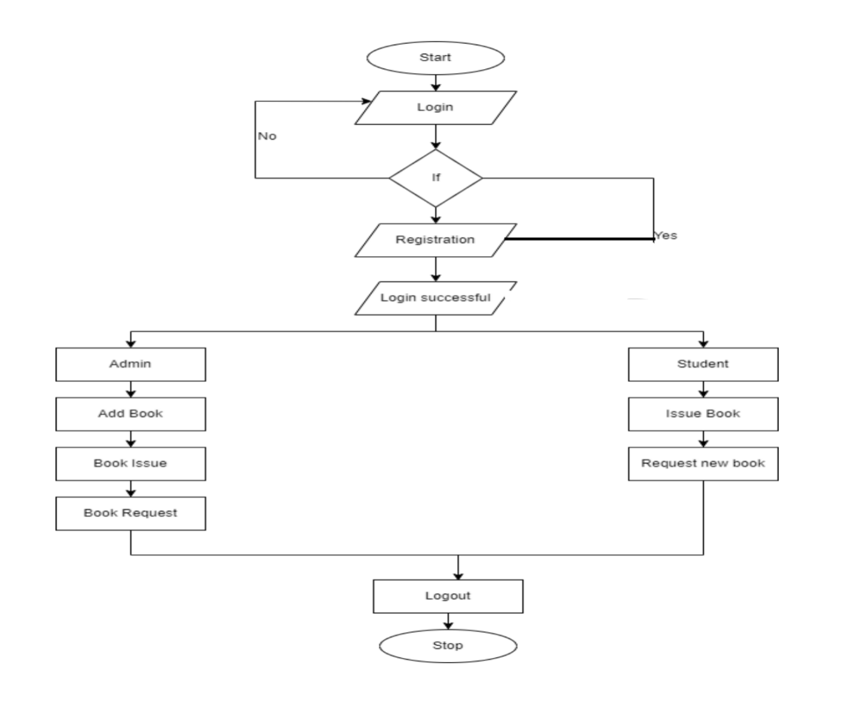

- 3.4 Data Flow Diagram

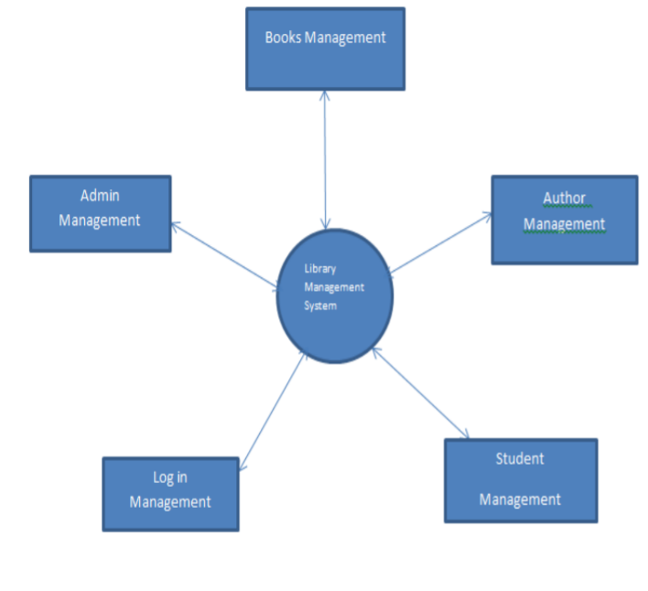
4.Data Dictionary

4.1 Table Name: Student

Field name | Datatype | Size | constraint | Description
S_id | Char | 13 | Primary Key | Student id
S_name | Char | 20 |  | Student name
S_branch | Char | 20 |  | Student branch
S_sem | Int | Int |  | Student sem
S_password | Char | 8 |  | Student password
S_email | Char | 20 |  | Student email
4.2 Book Table

Field name | Data type | Size | Constraint | Description
b_id | Char | 10 | Primary key | Book id
b_name | Char | 10 |  | Book name
b_author | Char | 10 |  | Book author

4.3 Admin Table

Field name | Data type | Size | Constraint | Description
a_id | Char | 15 | Primary key | Admin id
a_name | Char | 25 |  | Admin name
a_password | Varchar | 15 |  | Admin password

4.4 Category Table

Field name | Data Type | Size | Extra | Key | Description
Cat_id | Int | 11 | Auto_increment | Primary key | Category id
Cat_name | Varchar | 25 |  |  | Category name
Cat_desc | Varchar | 25 |  |  | Category describe
cat_createtable | Datetime |  |  |  | Category create table

5.Snap-Shots

5.1 Student Registration
5.2 Student sign in
5.3 Admin sign in
5.4 Welcome admin
5.5 Issue Book
5.6 Request for unavailable Book
5.7 Change Password

- 5.1 Student Registration

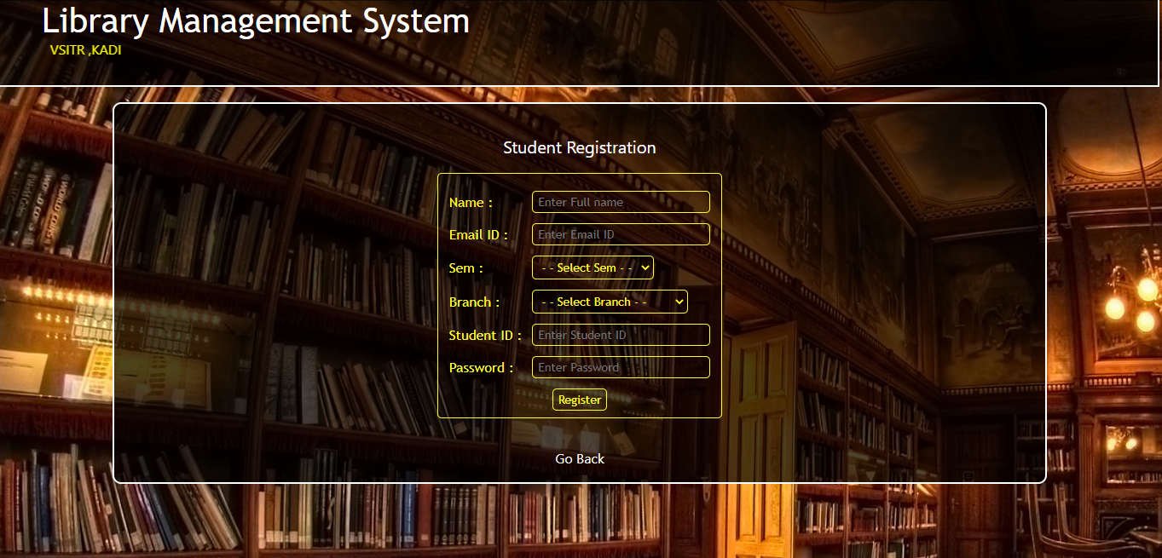

- 5.2 Student sign in

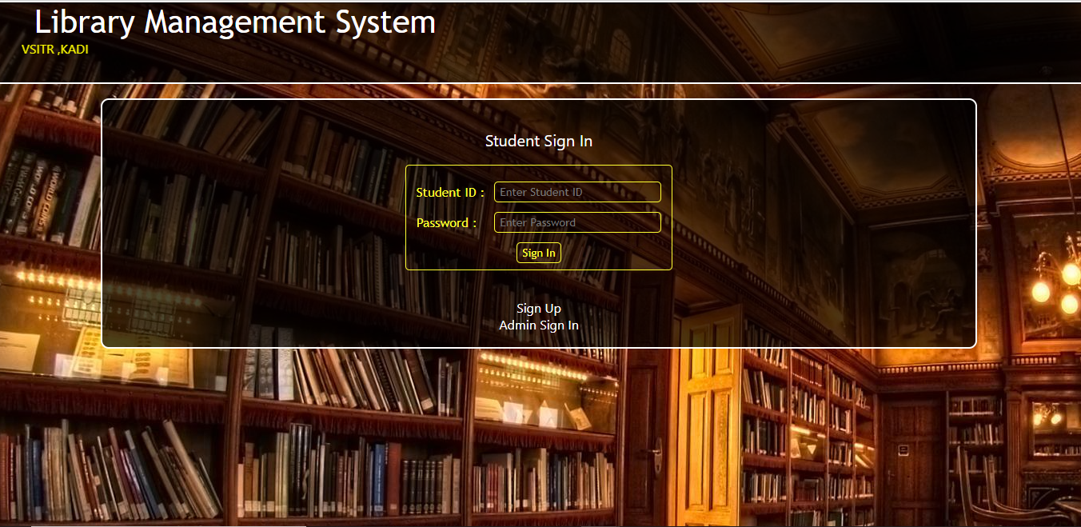

- 5.3 Admin sign in

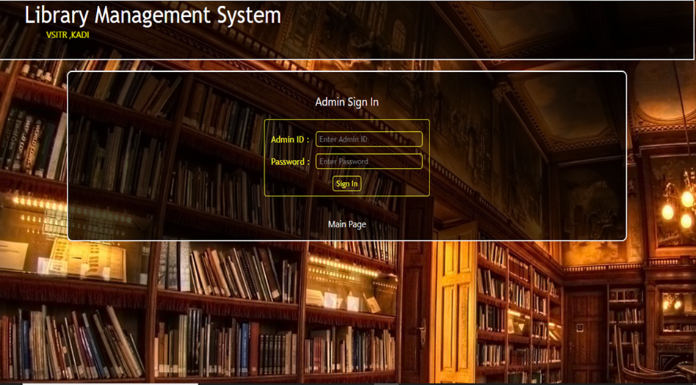

- 5.4 Welcome Admin

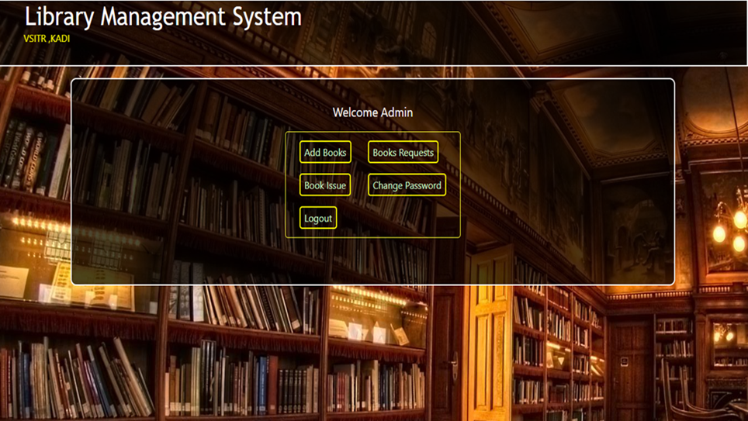

- 5.5 Issue Book

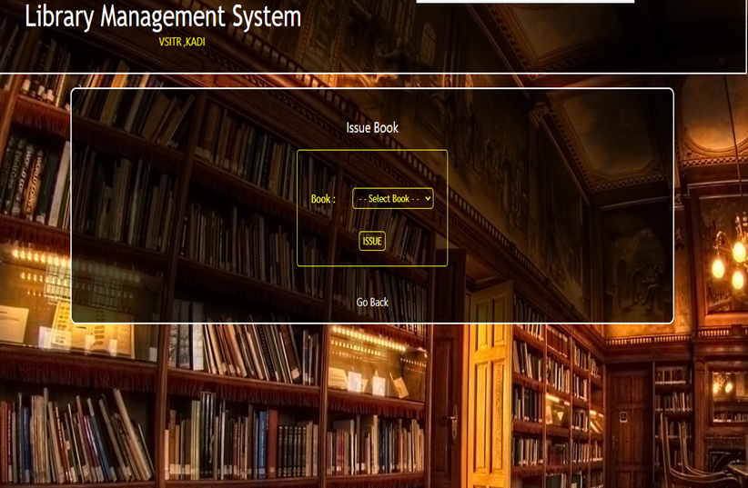

- 5.6 Request For Unavailable Book

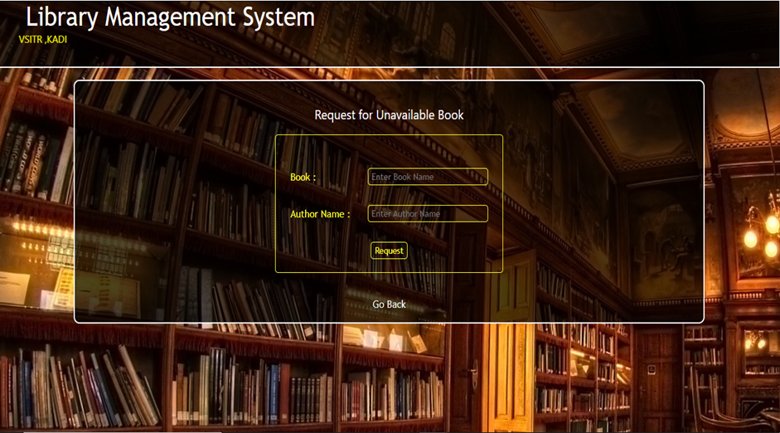

- 5.7 Change Password

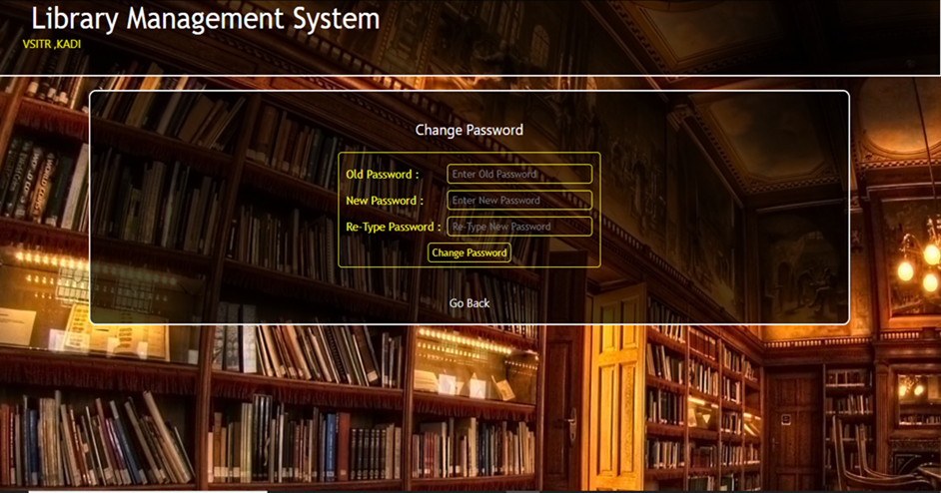

- Bibliography

- Book Name:

- Oxford English Mini Dictionary
- The Power of Your Subconscious Mind
- Believe In Your Self
- Rich Daddy Poor Daddy

- Website Name:

1. https://lio.io/
2.https://play.google.com/store/apps/details?id=com.threeclick.golibrary&hl=en_IN&gl=US
3.https://books.google.com/books?uid=117522004192189783614
4. https://ndl.iitkgp.ac.in/
5. http://www.librarything.com/

